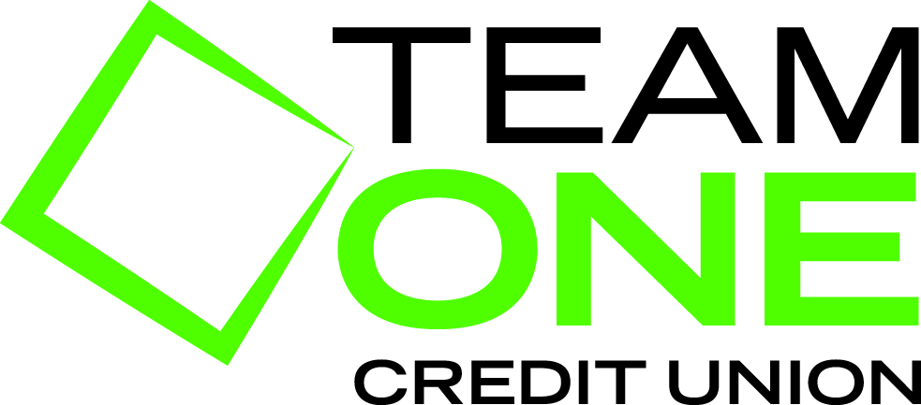
Team One Credit Union
TOCU-R140401 “Home Loans”
:60 Radio

Announcer
Thinking about purchasing a new home?
How about refinancing your current mortgage to save money every month?
Or maybe you’re considering making some home improvements?

Don’t wait, take advantage of the great weather and our great rates and come see Team One Credit Union for your all your Home Loan needs! From fixed mortgages to home equity loans, Team One offers a variety of Home Loan products to suit your needs. Take comfort in knowing that when you finance your home with Team One, we’ll be with you every step of the way. From application to closing; we make the process easy & enjoyable!

So, if you’re considering refinancing or purchasing a home, now would be the perfect time to call Team One at 888-288-3261 or visit TEAM ONE C-U dot org, and see why Team One is fast becoming Michigan's Mortgage lender of choice!

Announcer
We do business in accordance with the Federal Fair Housing Law and Equal Credit Opportunity Act. Member NCUA.

Team One Credit Union. Banking…Only better for over 75 years!

